**DAILY ONLINE ACTIVITIES SUMMARY**

|  |  |  |  |  |  |  |  |  |
| --- | --- | --- | --- | --- | --- | --- | --- | --- |
| **Date:** | **12/08/2020** | | | | | **Name:** | **NAIPUNYA VINOD NAIK** | |
| **Sem & Sec** | **IV SEM & A SECTION** | | | | | **USN:** | **4AL18CS050** | |
| **Online Test Summary** | | | | | | | | |
| **Subject** | | **NO INTERNALS CONDUCTED TODAY** | | | | | | |
| **Max. Marks** | | **30** | | **Score** | | | **-----------------------** | |
| **Certification Course Summary** | | | | | | | | |
| **Course** | **1)CYBERSECURITY AND THE INTERNET OF THINGS** | | | | | | | |
| **Certificate Provider** | | | **1)COURSERA** | | **Duration** | | | **1)12 HRS** |
| **Coding Challenges** | | | | | | | | |
| **Problem Statement: ARRAYS HACKERRANK PROBLEM** | | | | | | | | |
| **Status:------------------------** | | | | | | | | |
| **Uploaded the report in Github** | | | | | **YES** | | | |
| **If yes Repository name** | | | | | <https://github.com/naipunya-naik/Online-Coding-platform-coding/blob/master/Arrays_12-08-2020.cpp>  <https://github.com/naipunya-naik/daily-progress-report> | | | |
| **Uploaded the report in slack** | | | | | **YES** | | | |

Online Test Details: (Attach the snapshot and briefly write the report for the same).

NO INTERNALS CONDUCTED

Certification Course Details: (Attach the snapshot and briefly write the report for the same).

1. CERTIFICATION COURSE NAME:- CYBERSECURITY AND THE INTERNET OF THINGS.

TODAY I STARTED A NEW COURSE ON COURSERA, I COMPLETED TWO WEEK COURSE.

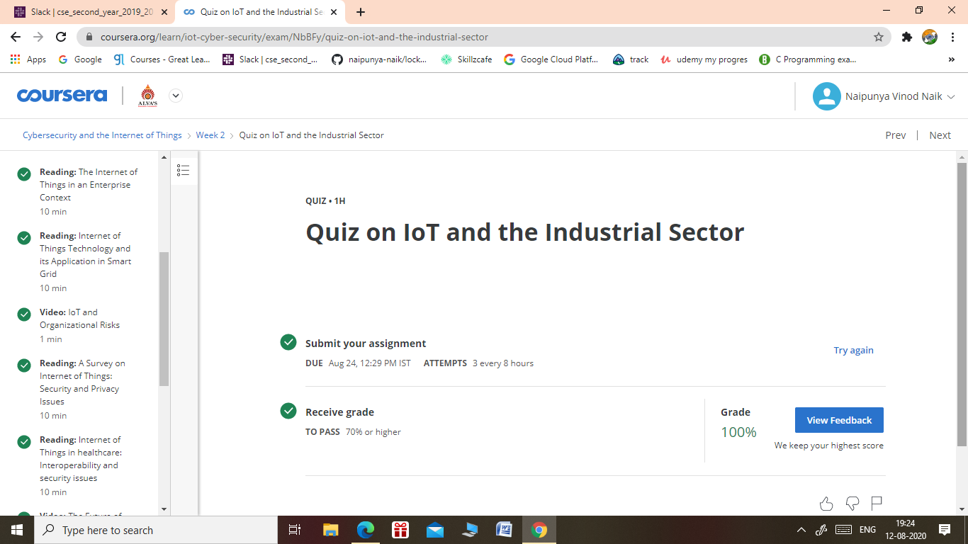

Coding Challenges Details: (Attach the snapshot and briefly write the report for the same).

PROBLEM STATEMENT:-

**Task**  
Given an array, of  integers, print 's elements in reverse order as a single line of space-separated numbers.

**Input Format**

The first line contains an integer,  (the size of our array).  
The second line contains  space-separated integers describing array 's elements.

**Constraints**

where  is the  integer in the array.

**Output Format**

Print the elements of array  in reverse order as a single line of space-separated numbers.

**Sample Input**

4

1 4 3 2

**Sample Output**

2 3 4 1

TODAY I ATTEMPTED AN ARRAY PROBLEM STATEMENT FROM HACKERRANK AND I PASSED ALL TEST CASES AND UPLAODED THE CODE IN MY GITHUB REPOSITORY.

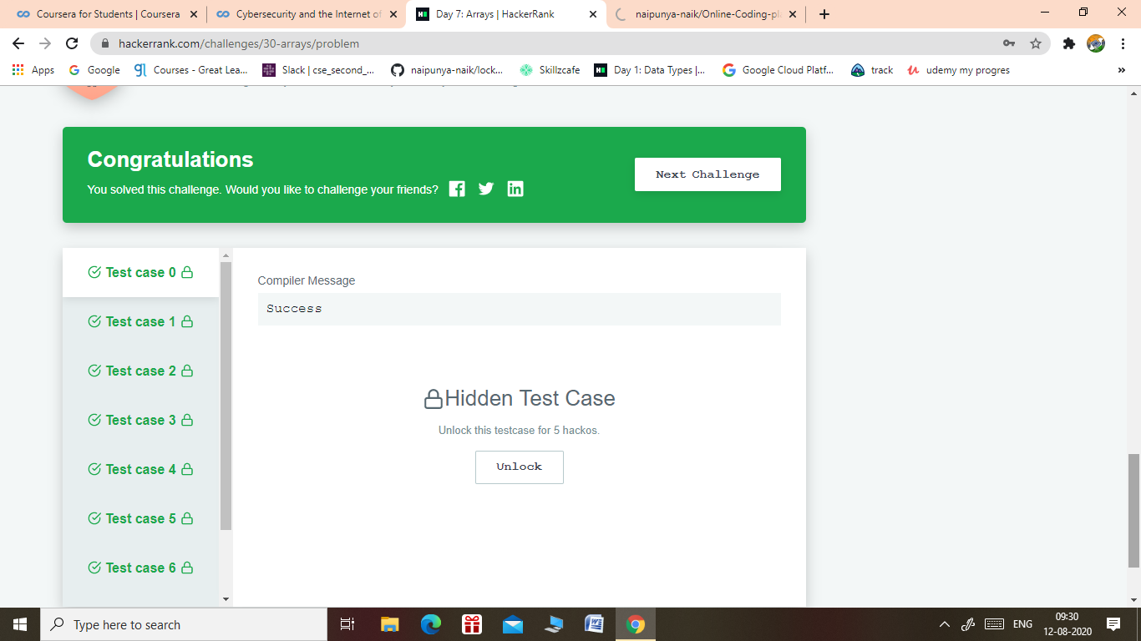

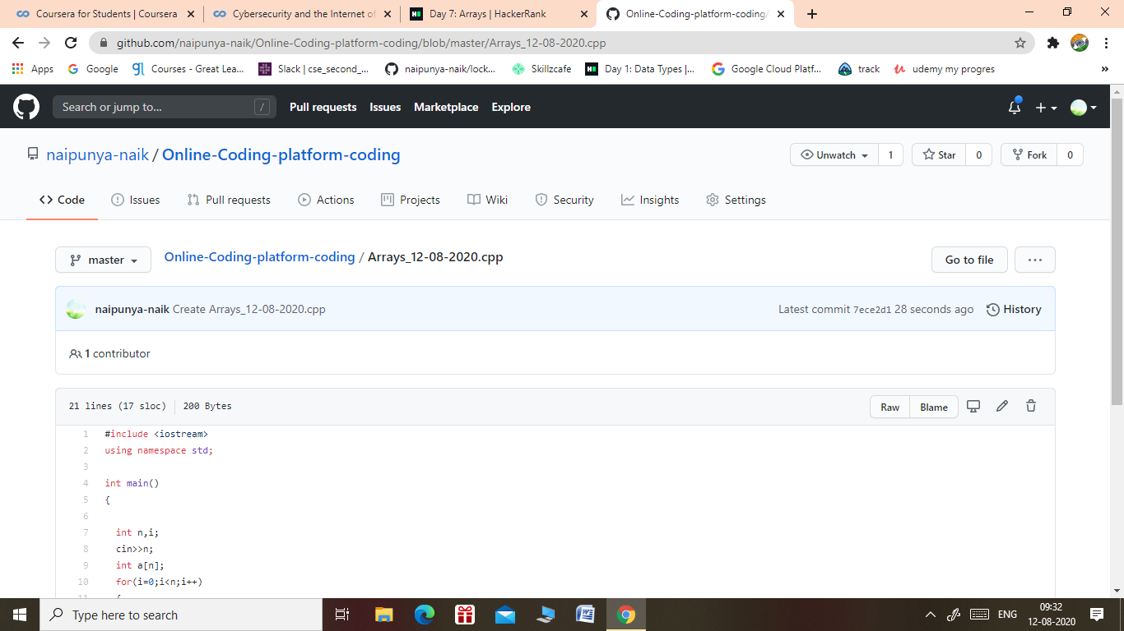

GITHUB REPOSITORY LINK:-

<https://github.com/naipunya-naik/Online-Coding-platform-coding/blob/master/Arrays_12-08-2020.cpp>